ABC TECHNOLOGIES

Clone the project from the GitHub link shared in resources to your local machine. Build the code using Maven commands

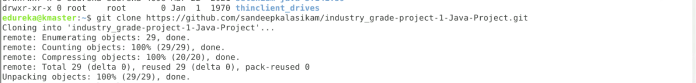

Maven Compile

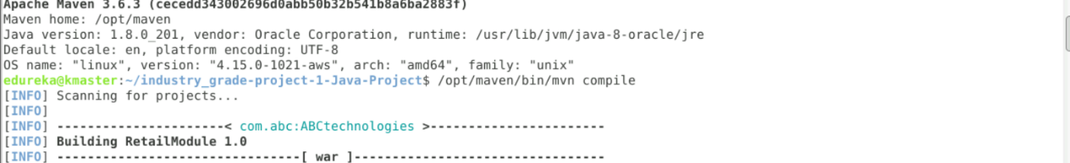

Maven Package

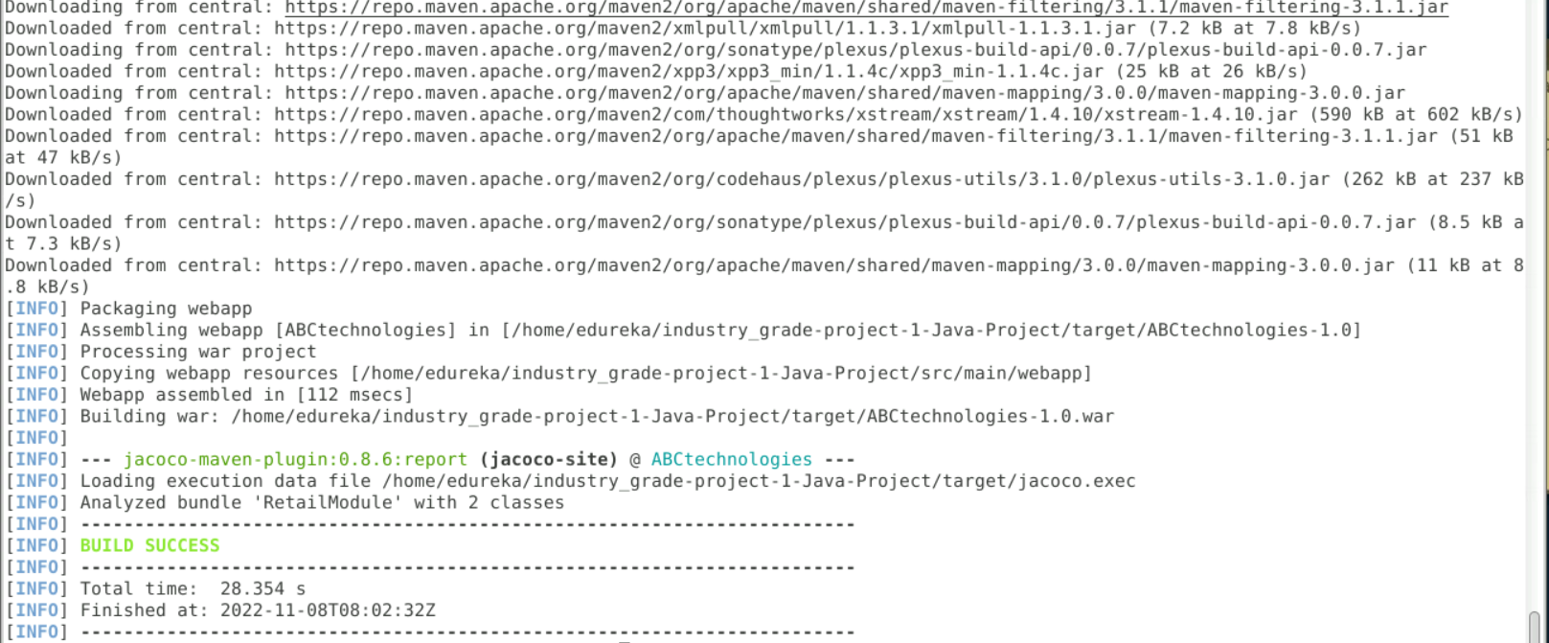

Once Build Success we have to ls -l go to target folder their ABCtechnologies-1.0.war file is located

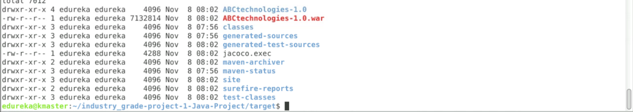

Jenkins compile job

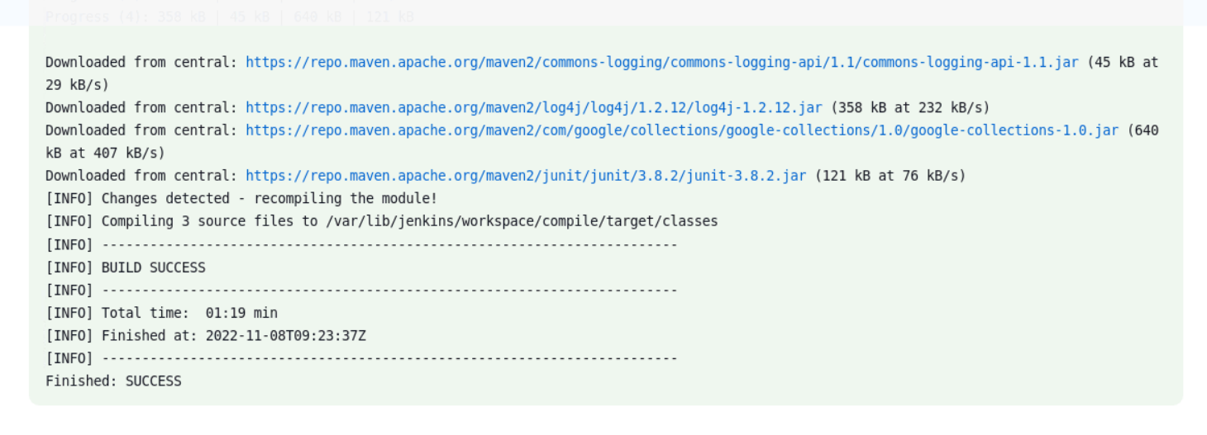

Jenkins Package

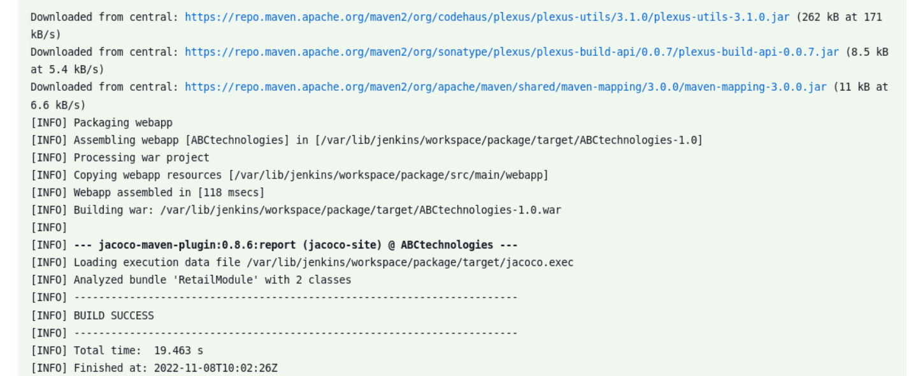

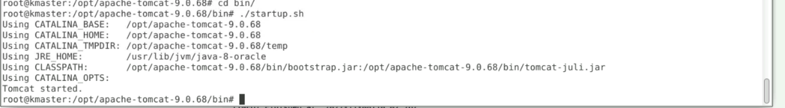

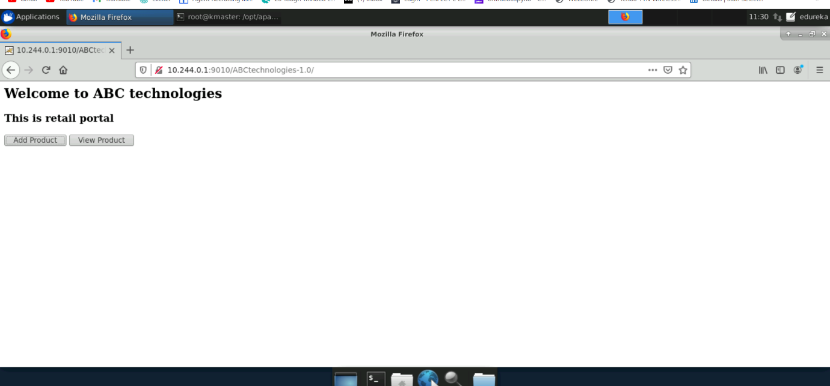

Master & Slave Agent Configuration

GO---Manage Jenkins---Manage Nodes & Cloud

Add New Node with name slave node

While adding slave node configuration we have java compatibility issue .We need to uninstall and then install latest version of Java.

Need to set Java Home & Maven Home on /etc/profile

Once we add Java & Maven Home : Need to run command source /etc/profile

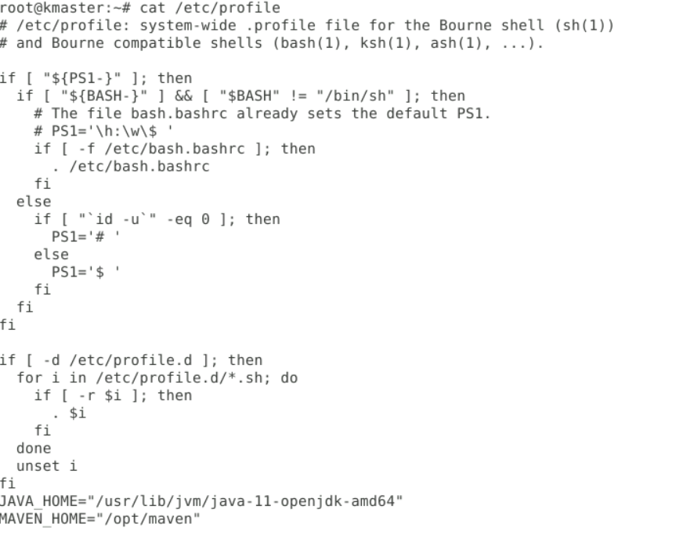

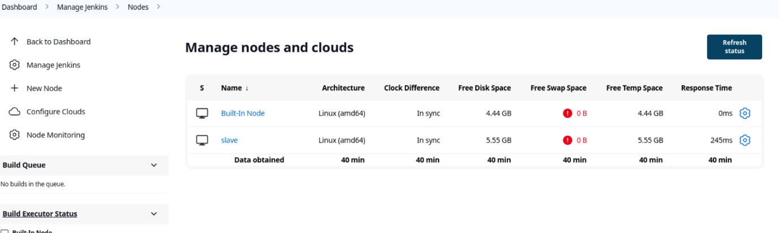

In Configuration setting remote directory and path should be given so that output is recorded in that folder

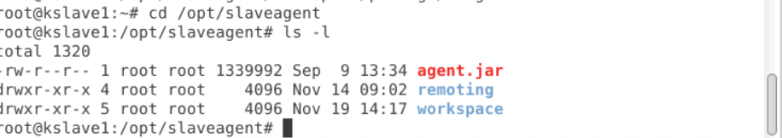

Connection status of Slave

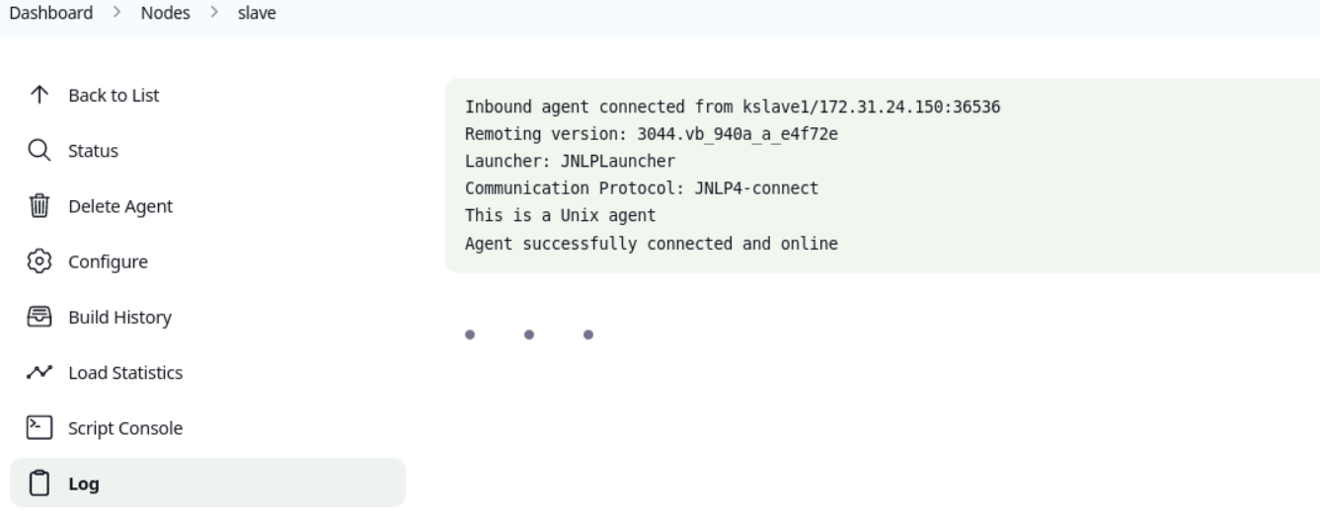

Compile out built on slave agent

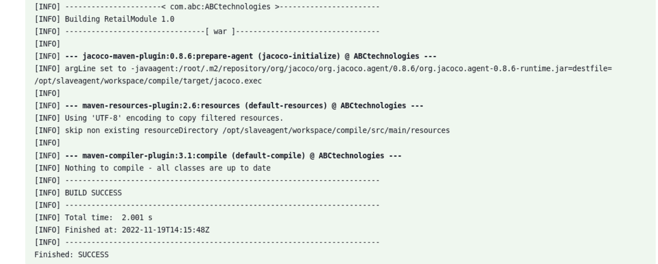

Package out is directed to slave agent by the master and out is stored in /opt/slaveagent/workspace/package below output

